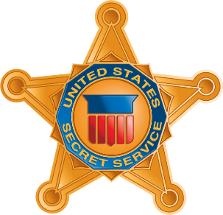
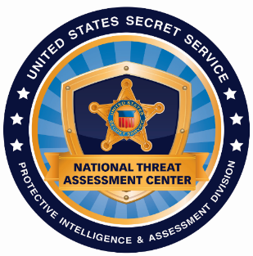

The U.S. Secret Service and VT’s Agency of Education and Department of Public Safety
invite you to attend a FREE event:

U.S. Secret Service Research and Recommendations
on the Prevention of Targeted School Violence

For over 20 years, the U.S. Secret Service National Threat Assessment Center (NTAC) has conducted research on the thinking and behaviors of those who commit acts of targeted school violence, in an effort to prevent future tragedies. Key findings from this research indicate that establishing multidisciplinary behavioral threat assessment teams and encouraging the reporting of concerning behaviors are critical steps in the prevention of targeted violence.

This presentation will explore relevant past incidents, as well as findings and recommendations from NTAC’s latest research on targeted school violence and averted school attacks in the United States. It will also focus on how communities can use a multidisciplinary approach to identify, assess, and intervene with students exhibiting concerning or threatening behaviors as early as possible.

This event is intended for school superintendents/administrators, teachers, and school mental health staff.

All attendees must pre-register and RSVP by contacting: sunni.eriksen@vermont.gov

This is NOT active shooter response training.
Intended Audience

- Education Administrators
- Teachers
- School Psychologists/Guidance Counselors
- Crisis Intervention Units
- Counselors & Mental Health Specialists
- Social Workers
- Anyone who may potentially be involved in risk detection/management position
Event Details

Date: March 16th, 2023
Time: 9:00 am to 1:00 pm
Location: Innovation Hall, Room E102, University of Vermont Campus
Parking Pass to be e-mailed prior to the event!

For questions or information, please contact: Sunni Eriksen, School Safety Program Manager at sunni.eriksen@vermont.gov

