Featured story:   
Vermont School Safety Initiative (A Brief Look)

Rob Evans, Vermont School Safety Liaison…1

All Students Deserve Safe Schools

Don Tinney, Vermont NEA, Union of Vermont Educators…2

All Students Deserve Safe Schools continued…3

School Emergency Preparedness…5

School Safety thoughts from Commissioner Mike Schirling, Vermont Department of Public Safety…3

Be Prepared-Not Scared: School Nursing and Emergency Preparedness in Vermont Sharonlee Trefry, State School Nurse Consultant

Vermont…4

State of Virginia School Safety Conference…5

School Safety and Impact

Charlotte McCorkel, LICSW, Senior Director of Client Services, Howard Center…6

Managing School Threats Through the Vermont Intelligence Center Ron LaFond, Deputy Director, Vermont Intelligence Center …6

Managing School Threats Through the Vermont Intelligence Center

continued …7

October 2019

Participants will also be provided 12 unique tabletop exercise designed for school leaders to test and evaluate their existing emergency preparedness plans, policies, and procedures.

**Phase III**:  Phase III will begin in January 2020 and will continue through until June 2020. Phase III will focus on delivering 60 individual training sessions throughout the state. These trainings will inform participants of the emerging trends in school safety and will provide attendees with the knowledge, skills, and abilities to effectively respond to a variety of potential emergencies at their school.

Immediately following this training, Margolis Healy staff offer the opportunity to facilitate Table Top Exercise for the leadership teams of the schools partnering with us during Phase III of this project.

Vermont School Safety Initiative (A Brief Look)

**Rob Evans, Vermont School Safety Liaison**

Vermont’s Agency of Education and Department of Public Safety have collaborated with [Margolis Healy](http://www.margolishealy.com/), on a school safety initiative to assist all of Vermont’s public and independent (K-12) schools with enhancing their level of school emergency preparedness by providing them with school safety planning, training and exercise assistance. This initiative is being rolled out in three (3) phases.

**Phase I:** Began in May of 2019 and consisted of a needs assessment survey that was sent to all of Vermont’s K-12 public and independent.  This assessment was designed to determine each schools level of emergency preparedness and was used to identify any challenges schools may be experiencing when trying to implement best and promising practices in school safety and security. A total of 258 schools completed the survey and all were invited to participate in Phase II.

**Phase II**: Phase II of this initiative began in early October and will run through December 2019. During this phase, Margolis Healy staff will deliver eight regional planning workshops designed to educate and inform school leadership teams in how to develop an emergency operations plan (EOP) and how to develop and deliver school safety drills and exercises.

For breaking news on the Vermont school safety front, follow us on Twitter:

[](https://twitter.com/vted_safeschool)

**@VTED_SafeSchool**

All Students Deserve Safe Schools

[](https://www.vtnea.org/)

**Don Tinney, Vermont NEA, Union of Vermont Educators**

I will begin this column with an expression of gratitude to the six Vermont-NEA members who encouraged their students to participate in our “See Something, Say Something” Public Service Announcement contest. Melissa Kristiansen of Poultney High School,

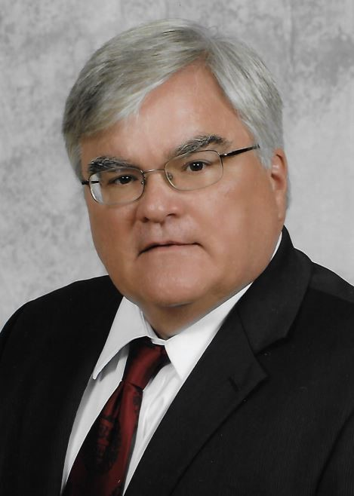

Cristina Kumka of Stafford Technical Center, Jessica LaBonte of Hazen Union High School, Zachary McNaughton if River Valley Technical Center, Clarena Renfrow of Rutland High School, and Anthony Sorrentino of Northwest Technical Center deserve our appreciation for engaging students and inspiring their creativity in the important work of encouraging their peers to talk with adults when they believe a friend is in need of help and support.

All of you have been engaged in a variety of discussions about school safety with your students. I hope the PSAs can serve as quick discussion-starters for you to continue these discussions in a class or advisory, particularly at the middle and high school levels.

Educators need to have conversations with their students about the difference between being vigilant and being a vigilante. Another nuanced conversation that needs to happen is about the risk of some students taking on the psychological burden of thinking they are responsible for the behavior of others; we can support others, but they are untimely going to make the choices they make by their own volition.

At the state, regional and local level, we continue to struggle to create solutions to the problem of school violence, knowing that while the probability of a school shooting is quite low, the threat is still real. There is no doubt that all the attention on school violence and all the drills and lockdowns have led to increased stress and anxiety amongst our students and our colleagues. Personally, when I was in the classroom, the lockdown drills always served as a reminder of just how vulnerable my students were.

We somehow must find a balance between being prepared for a violent attack and allowing our students to live lives of joy and wonder without fear and anxiety.

No matter the challenges and obstacles, we are committed to making sure that every single school is a sanitary for students. Protecting our students from harm is our first and foremost responsibility. Vermont-NEA members have devoted their lives to creating safe, compassionate learning environments for their students. While the outside intruder poses a possible threat to students and staff, our members are facing other, more immediate obstacles in their efforts to maintain safe learning environments every day that must be addressed now.

Thanks to a grant from the NEA’s Center for Great Public Schools, Vermont-NEA will host a summit on May 20th to address the challenges of creating safe, compassionate learning environments for all students. During our fall district meeting, our members clearly communicated to us that dealing with the increase in aggressive and violent student behavior was their top priority.

All Students Deserve Safe Schools, *continued*



This behavior not only disrupts learning for all students, it creates unsafe work environments for our members. We are looking forward to deep conversations with a range of decision makers in Burlington on May 20th, but we know that this will only be the beginning of a very long process of tackling this crisis. In a recent meeting with the president of Vermont Principals’ Association, we agreed that we need to accept the fact that this will take a generation to resolve. We are dealing with societal issues that are out of our control but that arrive at the schoolhouse door every day---food insecurity, homelessness, income inequality which leads to parent working two or three jobs,

alcoholism, the opioid crisis, digital screen time addiction, entitlement, and domestic violence are just some of the external factors that are having an impact on student behaviors. I need not remind you that the behaviors we are witnessing are the result of students not having their needs met; but knowing that does not erase the pain and stress of physical or verbal attack, leading to secondary trauma, forms of PTSD, and elevated stress levels. While we understand the importance of self-care in the workplace, we also know that educators are not always proficient at taking care of themselves. After our summit on May 20th, we will be communicating our plans for this work at the state, regional and local level. Stay tuned. Thank you for all you do in service to the children and youth of Vermont.

School Safety thoughts from Commissioner Mike Schirling, Vermont Department of Public Safety

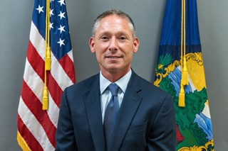

School safety is a priority for Governor Scott and the Department of Public Safety. It is an honor to be among the newest team members responsible for keeping kids and staff safe and secure.

Over the past two years, significant effort has been made, and millions of dollars have been provided to school districts to enhance school safety.

We will continue to look for opportunities to access resources for this important work. The department and the Vermont School Safety Center have adopted a strategic approach to create safe and welcoming learning environments in Vermont schools.

Our  most recent initiatives have created a unique and robust set of tools for administrators to utilize in planning for potential threats at their school. Safety planning assistance, training to recognize threats, and other resources are available for school districts. Administrators can access these resources by contacting the Vermont School Safety Center.

 I know the tremendous responsibility our staff, and those in Vermont schools, shoulder to ensure students feel, and are, safe when they go to school.  I look forward to working with schools, the VSSC and all partners as we continue this important work.

Get Connected, Get Answers!

All schools



Every parent expects their child to be safe at school. Statistics show that schools are some of the safest places to be ([CVPTF Report, 2019](http://cvptaskforce.vermont.gov/sites/vpt/files/documents/Executive%20Order%20No%203-18%20Community%20Violence%20Prevention%20Task%20Force%20Final%20Report%205-31-19.pdf); [MVA, Aug.2019](https://www.thenationalcouncil.org/wp-content/uploads/2019/08/Mass-Violence-in-America_8-6-19.pdf)), and teamwork is key to making that happen. Healthy relationships are the foundation of productive teams. A key team member in promoting safe schools is the school nurse; they play a role in every school crisis prevention team ([NASN, 2019](https://www.nasn.org/advocacy/professional-practice-documents/position-statements/ps-emergency-preparedness)). School nurses use their expertise in assessment, outcomes identification, planning, implementation and evaluation to help teams work through the five phases of emergency management: prevention, protection, mitigation, response, and recovery ([The Role of Districts in Developing High-Quality School Emergency Operations Plans, 2019](http://rems.ed.gov/docs/District_Guide_508C.pdf)). Starting with prevention, school nurses are essential to a positive school climate.

**Sharonlee Trefry,**

**State School Nurse Consultant Vermont Department of Health, Division of Maternal & Child Health**

They are the safe and trusted adult for many students and their families. School nurses can be the first ones to become aware of distraught students or symptoms of anxiety or disruptions in mental health. From planning for the response of students with seizures to flashing evacuation lights, ensuring that those with diabetes have access to life-saving medicine during lockdowns, to triaging treatment for the injured during mass casualties school nurses have a role in all phases. Not everyone is at the table at every meeting so school administrators and nurses should plan for at least bi-annual planning, training, and debriefing opportunities. School nurses and administrators need to advocate for the time and the compensation to be part of planning for all-hazard emergencies. Knowing what is in the district or school's emergency policies, protocols, and procedures takes active learning time. The same goes for understanding the communication process. It may even mean updating written evacuation plans for individual students and training other school personnel to manage situations in the absences of the school nurse.

All hazard preparation means having adequate numbers of school personnel who are certified in CPR and First Aid *on campus daily.* Be prepared – not scared! Check out these and more: [School Nurse Go-Bags](https://schoolsafety.vermont.gov/sites/ssc/files/Go%20Bags%20-%20Dept%20Health%20Suggestions.docx) and [Infectious Disease Response](https://schoolsafety.vermont.gov/sites/ssc/files/documents/SchoolSafetyPlanning/VTSchoolCrisisGuide/Response/Infectious%20Disease.xls). More resources for can be found in the [Standards of Practice: School Health Services Manual](https://www.healthvermont.gov/family/school/standards-practice-school-health-services-manual) and the [Vermont School Safety Center](https://schoolsafety.vermont.gov/resources/agency-websites).

Be Prepared – Not Scared: School Nursing and Emergency Preparedness in Vermont

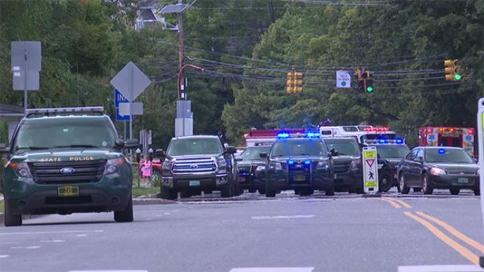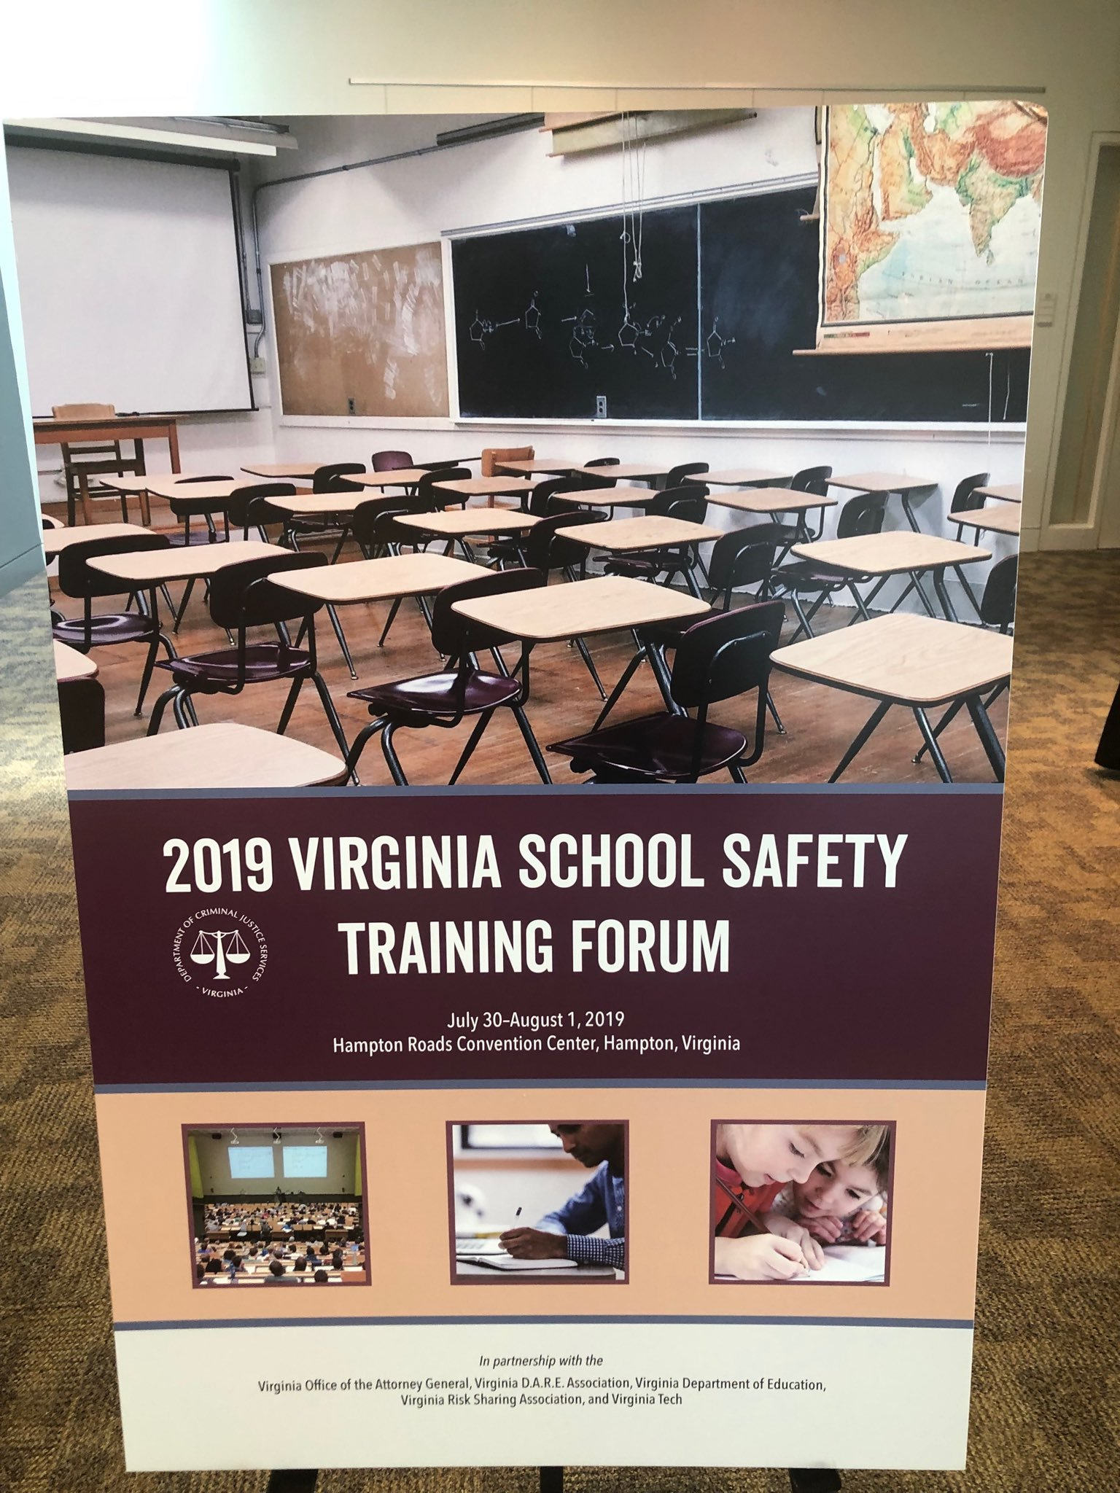

Photo: First Responders on scene at the Vermont Tax Department building at 133 State Street, August 30, 2019.  As law enforcement personnel responded to a report of a man with a rifle inside the tax department, the nearby Montpelier High School was put into “lockout” condition as a precaution.

Coordination of communication between the schools and the first responders can go a long way in effectively managing an emergency.

Timely, concise, and accurate information to those affected during a threatening event, or exercise accomplishes several things: it provides guidance to those immediately impacted, it informs parents that the school may be in a specific condition such as “lockout,” and school safety communication in conjunction with outsidepublic safety messaging from an incident command post can alleviate misinformation, traffic congestion, and even fear.

As schools settle-in to the fall semester, this is a good time to meet with local first responders and discuss emergency plans, upcoming scheduled drills, and address any emergent needs within the school district that require the school safety team’s immediate attention.  Whether it is the roll-out of a new student/faculty safety technology, or a new district emergency protocol—it is vital to talk about communication.   The coordination of communications, both internally and externally, should be a regular part of any safety team’s planning process.

School Emergency Preparedness

State of Virginia School Safety Conference

In July, Rob Evans (Vermont State School Safety Liaison), Brooke Farrell (Superintendent Slate Valley School District), Jason Rasco (Principal, Fair Haven High School), Rosemary Kennedy (Rutland County State’s Attorney), Henry Alberico (Detective Sergeant, VSP), and Bill Humphries (Chief of Police, Fair Haven PD) traveled to Hampton, Virginia to deliver a keynote address to a crowd of 1500 law enforcement and school administrators at the State of Virginia School Safety Conference.  The keynote focused on the averted school attack on Fair Haven Union High School in February of 2018.

The importance of building strong collaborative relationships between stakeholder groups and See Something, Say Something were highlighted as reasons the attacked was averted. The group also spoke about how the case influenced the adoption of new laws and changed the face of school safety throughout the state of Vermont.

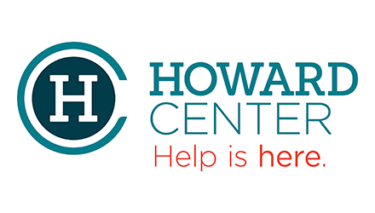

responses are executed when an incident occurs, drills, are keys to ensuring the safest and appropriate responses are executed when an incident occurs.

The balance is to “conduct trainings that make best use of resources, maximize effectiveness, and minimize physical and psychological risks” ([Best Practice Considerations for Schools in Active Shooter and Other Armed Assailant Drills, p. 2; Updated 2017.](https://schoolsafety.vermont.gov/sites/ssc/files/documents/Resources/Best%20Practice%20Considerations%20for%20Schools%20in%20Active%20Shooter%20and%20Other%20Armed%20Assailant%20Drills.pdf))

There are many resources available to us:

* [Considerations for Schools in Active Shooter and Other Armed Assailant Drills](https://schoolsafety.vermont.gov/sites/ssc/files/documents/Resources/Best%20Practice%20Considerations%20for%20Schools%20in%20Active%20Shooter%20and%20Other%20Armed%20Assailant%20Drills.pdf)
* [Guide for Preventing and Responding to School Violence](https://www.bja.gov/publications/iacp_school_violence.pdf)
* [Mitigating Psychological Effects of Lockdowns](https://www.nasponline.org/resources-and-publications/resources-and-podcasts/school-climate-safety-and-crisis/systems-level-prevention/mitigating-psychological-effects-of-lockdowns)
* Tips for Talking With and Helping Children and Youth Cope After a Disaster or Traumatic Event: A Guide for Parents, Caregivers, and Teachers

School safety is a priority in our community. Vermont is no stranger to the impact of school shootings, threats to students and other alarming incidents. Planning and preparedness, including the safest and appropriate

School Safety and Impact

**Charlotte McCorkel, LICSW, Senior Director of Client Services, Howard Center**

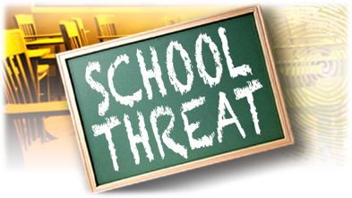

Beginning in the 2018/2019 academic school year the Vermont Intelligence Center (VIC), the Vermont State Police and the Vermont School Safety Center partnered together to establish a mechanism to track school safety threats throughout Vermont.

The Vermont Intelligence Center can assist with a reported threat by utilizing social media and numerous law enforcement databases to determine the validity of the threat and share pertinent information with investigating agencies and appropriate school authorities to hopefully thwart the reported threat and ensure the safety of all involved.

Managing School Threats Through the Vermont Intelligence Center

**Ron LaFond, Deputy Director, Vermont Intelligence Center**



to assist with information sharing and in the investigation of all major crimes in the State of Vermont. They provide intelligence products and assess State and Local implications of potential terroristic threats (domestic/ international) and criminal activity. The VIC conducts all activities in a manner that protects the privacy, civil rights, and civil liberties of the citizens and guests of Vermont and the United States of America by strictly adhering to a transparent privacy policy.

For those that are unfamiliar with what the Vermont Intelligence Center, Vermont’s only recognized Fusion Center in the state is, the VIC provides multidisciplinary expertise and situational awareness to inform decision making at all levels of government (local, county, state and federal law enforcement, as well as our public and private sectors partners) in order to protect our citizens, guests, and Vermont’s critical infrastructure from all crimes, threats and terrorism. The VIC serves as the central point of contact

Managing School Threats Through the Vermont Intelligence Center *continued*…

For more information on Vermont School Safety initiatives please contact:

Rob Evans

Vermont School Safety Liaison and Manager of Organizational Assessment & K12 Services

Email: [REvans@margolishealy.com](mailto:REvans@margolishealy.com)

Phone: (802) 839-0448